Deployment Guide - Receipt Keeper

# introduction

Receipt Keeper is composed of Node.js server, MongoDB, AngularJS, Android application Fig 1. Although the development was conducted on HEROKU PAAS, mLab DAAS environment, this document will explain about deployment of the application at local server with using locally installed MongoDB.

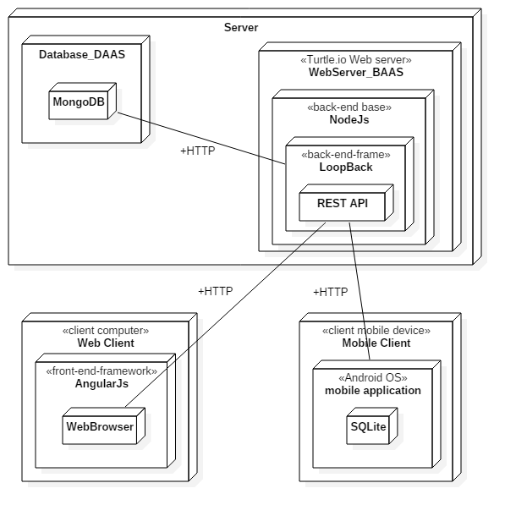

Fig. 1. Deployment Diagram

# Requirements

There is no specific requirement regarding OS and Hardware. For software version, we have used following version, but latest version with the same sub version have no problem.

- NodeJS v4.4.0  
- Mongodb v3.2.1

# Set up Mongodb

a) Download MongoDB from this site:

<https://www.mongodb.com/download-center#community>

For Windows 7 or newer version, download Windows 64-bit 2008 R2+

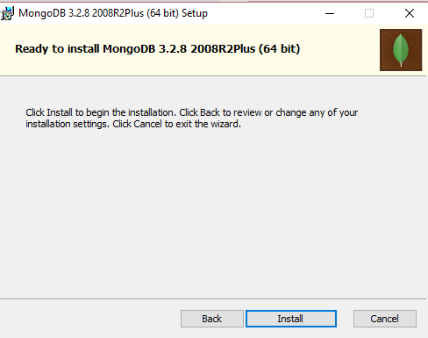b) On successful installation of the mongo database we have to set the Mongo installation path “C:\Program Files\MongoDB\Server\3.0\bin” under the System Path variables so as to get the mongo commands recognized

c) To setup user and password, open terminal window

mongod --dbpath the location where you want to create the database for example --dbpath "c:\Users\your user name\Products\Mongo\database

This will start the mongo server and it will listen on the default port 27017

d) Open another terminal windows, and run mongoshell and add user and set the role

# INSTALL NODE.JS / npm

C:\Users\Changho Choi> mongo

MongoDB shell version: 3.2.8

connecting to: test

> use receipt_keeper

switched to db receipt_keeper

> db.createUser({user:"receipt_keeper", pwd:"12345",roles:[{role:"readAnyDatabase",db:"admin"},"readWrite"]})

Successfully added user: {

"user" : "receipt_keeper",

"roles" : [

{

"role" : "readAnyDatabase",

"db" : "admin"

},

"readWrite"

]

}

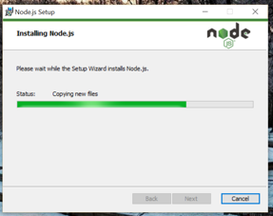Downlaod NodeJS from this site: <https://nodejs.org/en/download/>

During the install,

Select option "Add to PATH"

Install npm package manager either.

# setting up datasource.json

Modify ~/server/datasources.json to setup data source as MongoDB.

The username, password, database name are the same as the information set at Step3

"MongoDB": {

"host": "localhost",

"port": 27017,

"url": "mongodb://localhost:27017/receipt-keeper",

"database": "receipt-keeper",

"password": "pass",

"name": "MongoDB",

"user": "admin",

"connector": "mongodb"

}

# install relevant npm modules

rm –rf ./node_modules

npm install

7. Running Mongodb Daemon

mongod –dbpath *~/mongodb/data*

# 8. Running nodejs server

node ./server/server.js

# install android application

1. Download and install adb. This will not be cover here. Please refer to <https://developer.android.com/studio/command-line/adb.html> for the details.
2. Move to the folder where apk is located and Install app with the following command

adb devices

adb install receipt_keeper.apk

1. Run the android application and proceed to sign up (before running the android application, server should be running). After signup, if auto-login checkbox is checked, it will login automatically. At settings menu, select Server Address and set the address of server. After setting, data is uploaded by using of the address.

 